**High Level Design**

**Scope**:

The robot is equipped to navigate through the maze, detect heat sources and shoot ping-pong balls upon detection, with a time interval of 2s-4s-2s.

**Architecture Diagram:**

The following diagram illustrates how the various components of the system interact with each other.

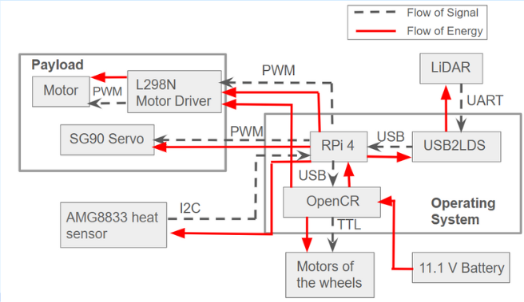

**Component Description:**

| Item No. | Qty | Part Name | + |
| --- | --- | --- | --- |
| 1 | 1 | S90 servo for heat sensor |
| 2 | 1 | AMG8833 sensor |
| 3 | 1 | Ball holder |
| 4 | 2 | Flywheel motor |
| 5 | 2 | Flywheel |
| 6 | 1 | S90 servo for rack and pinion |
| 7 | 1 | Rack and pinion |
| 8 | 1 | Pipe support |
| 9 | 1 | Sensor servo holder |
| 10 | 1 | Acrylic Holder for Launcher |
| 11 | 1 | Weight |
| 12 | 1 | Turtlebot3 burger |  |

The map created by the lidar along with the odometry reading helps in updating the local and global costmap, along with giving the position of the robot on the map. The pipes are used to store the ping-pong balls. The AMG8833 heat sensor provides a 8x8 array of temperatures, which is used to scan for heat sources. Upon detection of heat sources, the rack and pinion along with the flywheel is activated, which shoots the ping-pong balls. The weight is used to balance out the weight of the motors and launcher, on the other side of the bot.

**Data/Control Flow:**

The flowchart below shows the logic diagram for heat detection:

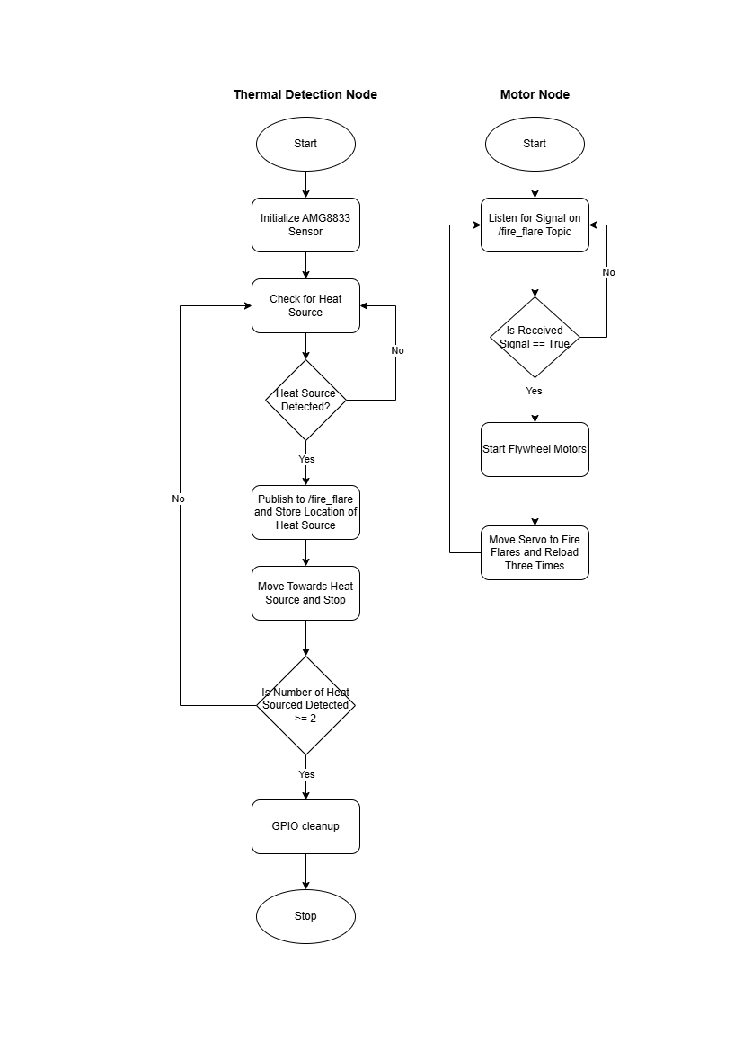

Fig: Logic diagram for heat detection

The flowchart below represent the logic diagram for navigation:

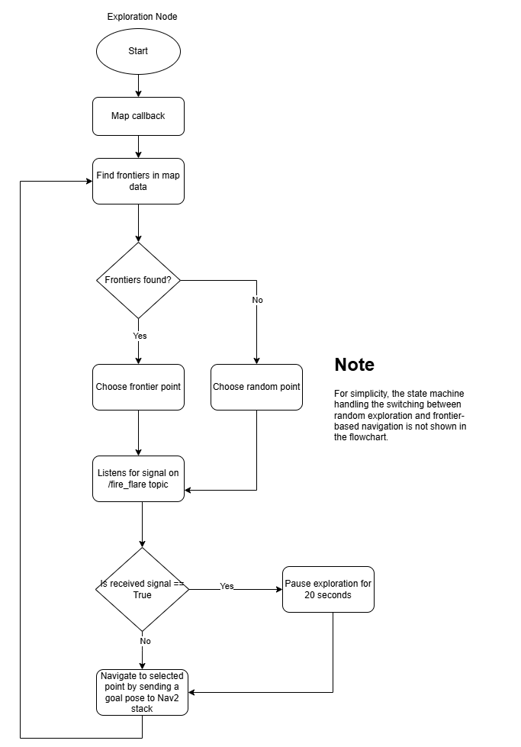

Fig: Logic diagram for navigation.

**Design Consideration:**

|  | **List** | **Specifications** | **Notes** |
| --- | --- | --- | --- |
| **Turtlebot** | Dimensions (mm) (LxWxH) | Turtlebot3 & Launcher:  293x262x212 |  |
| Weight (kg) | Launcher: 0.924  Turtlebot: 1.51  Counter-weight: 0.2  Total weight: 2.634 |
| Wheel Base (mm) | 80.66 | From center of DYNAMIXEL to the center of ball caster |
| DC Motor | 2x JGB37-520 |  |
| Servo Motor | 2x SG90 |  |
| **Payload** | Dimensions (mm) (LxWxH) | 40 x 40 x 40 | Ping Pong Ball |
| Weight (kg) | Ping Pong: 0.0027  Total: 0.0243 | 9 Ping Pong Ball |
| **System** | Battery Capacity | 1800 mAh |  |
| Expected Operating Time | 92.3 min |  |
| Communication Interface | GPIO,PWM,I2C,UART,USB,TTL, TCP |  |